Yes. Since you want one EC2 instance and a simple beginner-friendly implementation, I would simplify the architecture.
Use the EC2 instance as your CI tools/server machine and use GitHub Actions as CI. We will still deploy the application to EKS using Argo CD. Don't install unnecessary tools all at once.
What we are going to build
YOUR LAPTOP
│
│ git push
▼
GitHub Repository
│
▼
GitHub Actions
│
├── PHP validation
├── Python validation
├── Gitleaks
├── SonarQube scan
├── Docker build
├── Docker push
└── Update Kubernetes YAML
│
▼
GitHub
│
▼
Argo CD
│
Automatic Sync
│
▼
EKS
┌───────┼────────┐
▼ ▼ ▼
PHP Python MySQL
Your EC2 will initially be our administration/tool server:
EC2
├── Git
├── Docker
├── AWS CLI
├── kubectl
├── eksctl
└── SonarQube
I recommend Ubuntu 24.04, t3.large, about 30 GB disk while SonarQube is running on it. t3.medium can become uncomfortable once you combine SonarQube and your tooling.

PART 1 — Create EC2
In AWS Console:
EC2 → Instances → Launch instance
Use approximately:
Name:
student-cicd-server

AMI:
Ubuntu Server 24.04 LTS

Instance type:
t3.large

Storage:
30 GB

Key pair:
Create/select your .pem key
For the Security Group initially allow:
Port | Purpose | Source
22 | SSH | My IP
9000 | SonarQube | anywhereip
Don't expose port 9000 to 0.0.0.0/0 unless you have a specific reason.
Launch it.

PART 2 — Connect to EC2
From Git Bash on Windows:
chmod 400 your-key.pem
Then:
ssh -i your-key.pem ubuntu@YOUR_EC2_PUBLIC_IP
You should now see something similar to:
ubuntu@ip-172-31-x-x:~$
From this point, commands marked EC2 are executed here.

PART 3 — Update EC2
EC2
sudo hostnamectl set-hostname studentserver
/bin/bash
sudo apt update
sudo apt upgrade -y
Install basic tools:
sudo apt install -y \
git \
curl \
wget \
unzip \
jq
Check:
git --version

PART 4 — Clone your repository
EC2
cd ~
Then:
git clone https://github.com/harathi-mutyam/student-app-cicd.git
Enter it:
cd student-app-cicd
Check:
ls
You should see your project files such as:
admin/ , student/ , assets/ , config/ , python/ , sql/ , Dockerfile ,
docker-compose.yml , index.php , README.md
This is your project directory.

PART 5 — Install Docker
EC2
Use Docker's Ubuntu repository rather than the older Ubuntu docker.io package. Docker's current Ubuntu installation instructions use its apt repository and packages including docker-ce, docker-ce-cli, containerd.io, Buildx, and the Compose plugin.
Run:
sudo apt update
sudo apt install -y ca-certificates curl
Create the key directory:
sudo install -m 0755 -d /etc/apt/keyrings
Add Docker's signing key:
sudo curl -fsSL \
https://download.docker.com/linux/ubuntu/gpg \
-o /etc/apt/keyrings/docker.asc
sudo chmod a+r /etc/apt/keyrings/docker.asc
Add Docker repository:
echo \
"deb [arch=$(dpkg --print-architecture) signed-by=/etc/apt/keyrings/docker.asc] https://download.docker.com/linux/ubuntu \
$(. /etc/os-release && echo "${UBUNTU_CODENAME:-$VERSION_CODENAME}") stable" \
| sudo tee /etc/apt/sources.list.d/docker.list > /dev/null
Install:
sudo apt update
sudo apt install -y \
docker-ce \
docker-ce-cli \
containerd.io \
docker-buildx-plugin \
docker-compose-plugin
Check:
sudo docker --version
and:
sudo docker compose version

PART 6 — Allow Ubuntu user to run Docker
EC2
sudo usermod -aG docker ubuntu
Then:
exit
exit
SSH into EC2 again:
ssh -i your-key.pem ubuntu@YOUR_EC2_PUBLIC_IP
Test:
docker ps
If that works without sudo, Docker is ready.

PART 7 — First local application test
Before CI/CD, make sure the application actually works.
EC2
cd ~/student-app-cicd
Run:
docker compose build
Then:
docker compose up -d
Check:
docker compose ps
Ideally you'll see your PHP, Python and MySQL services.
Check logs:
docker compose logs
If everything is running, we've proved:
Source Code
↓
Docker Build
↓
Containers
↓
Application
This is an important milestone.

PART 8 — Test PHP
If your docker-compose.yml maps:
8080:80
temporarily add Security Group:
TCP 8080
Source: My IP
Then open:
http://EC2-PUBLIC-IP:8080
You should see your Student Management System.
Open as admin admin details username: admin password: admin123
If it doesn't work, fix this before proceeding to Kubernetes.

docker compose down

PART 9 — Install AWS CLI
EC2
Run:
cd ~
curl \
"https://awscli.amazonaws.com/awscli-exe-linux-x86_64.zip" \
-o awscliv2.zip
unzip awscliv2.zip
sudo ./aws/install
Check:
aws --version

PART 10 — AWS authentication
For the simplest learning setup:
Pen browser create access keys and secret keys for aiam user .use those keys.

aws configure
Enter:
AWS Access Key ID:
<your key>

AWS Secret Access Key:
<your secret>

Default region:
eu-central-1

Default output:
json
Then test:
aws sts get-caller-identity
You should receive your AWS account/user information.

PART 11 — Install kubectl
EC2
Because Kubernetes versions change, follow the current official installation rather than copying an old binary URL. The Kubernetes documentation provides the Linux kubectl installation procedure.
For x86-64 Ubuntu:
curl -LO \
"https://dl.k8s.io/release/$(curl -L -s \
https://dl.k8s.io/release/stable.txt)/bin/linux/amd64/kubectl"
Install:
sudo install -o root -g root \
-m 0755 kubectl \
/usr/local/bin/kubectl
Check:
kubectl version --client

PART 12 — Install eksctl
EC2
Run:
ARCH=amd64
PLATFORM=$(uname -s)_$ARCH
curl -sLO \
"https://github.com/eksctl-io/eksctl/releases/latest/download/eksctl_$PLATFORM.tar.gz"
Extract:
tar -xzf eksctl_$PLATFORM.tar.gz
Install:
sudo mv eksctl /usr/local/bin/
Check:
eksctl version
Now your EC2 has:
Git ✓
Docker ✓
AWS CLI ✓
kubectl ✓
eksctl ✓

For a real production setup, I'd use an EC2 IAM role instead of long-lived access keys. We can upgrade to that after your first working pipeline.

cd ~/student-app-cicd
sudo apt update
sudo apt install -y gnupg software-properties-common

Add HashiCorp key:
wget -O- https://apt.releases.hashicorp.com/gpg \
| gpg --dearmor \
| sudo tee /usr/share/keyrings/hashicorp-archive-keyring.gpg > /dev/null

Add repository:
echo "deb [signed-by=/usr/share/keyrings/hashicorp-archive-keyring.gpg] \
https://apt.releases.hashicorp.com \
$(lsb_release -cs) main" \
| sudo tee /etc/apt/sources.list.d/hashicorp.list

Then:
sudo apt update
sudo apt install -y terraform

cd terraform
terraform --version
terraform init
terraform apply -var-file="dev.tfvars"
press yes then press enter key

cd ..

aws eks update-kubeconfig \
--region eu-central-1 \
--name student-cluster

When finished:
kubectl get nodes
You should see:
NAME STATUS
ip-xxx Ready
ip-xxx Ready
At this point:
EC2
│
│ kubectl
▼
EKS
├── Node 1
└── Node 2

PART 14 — Create Kubernetes directories
EC2
cd ~/student-app-cicd
mkdir -p k8s
mkdir -p argocd
mkdir -p .github/workflows
Now:
ls
should include:
.github , argocd , k8s

PART 15 — Create namespace
EC2
Create:
vim k8s/namespace.yaml
Paste:
apiVersion: v1
kind: Namespace

metadata:
name: student-management
Save:
Esc key :wq!→ Enter
Apply:
kubectl apply -f k8s/namespace.yaml
Verify:
kubectl get namespaces

Now I want to push these changes to github repository from ec2 instance

git status
git diff
git add k8s/ # here give changed file names and folders only
git status
git commit -m "Update database configuration and add Kubernetes manifests"

GitHub Authentication from EC2
Step 1 — Configure Git username and email
git config --global user.name "harathi-mutyam"
git config --global user.email "ehmutyam@gmail.com"
Check:
git config --global user.name
git config --global user.email
Step 2 — Create GitHub Personal Access Token
In GitHub: Profile → Settings → Developer settings → Personal access tokens → Fine-grained tokens → Generate new token
Select: Repository: student-app-cicd
Permission:
Contents → Read and write , Actions Read and write
Generate and copy the token.
Do not share or save the token inside your project.
Step 3 — Check changes
cd ~/student-app-cicd
git status
Step 4 — Add files
git add . or git add k8s/
Step 5 — Commit
git commit -m "Update database configuration and add Kubernetes manifests"
Step 6 — Push to GitHub
git push origin main
When asked:
Username: Enter harathi-mutyam
When asked:
Password: Paste the GitHub Personal Access Token, not your normal GitHub password.
Step 7 — Verify
git status
Expected: On branch main
Your branch is up to date with 'origin/main'.
nothing to commit, working tree clean

Normal workflow later
Whenever you change your project:
git add . or git add <changedfiles names>
git commit -m "your message"
git push origin main
Username for 'https://github.com': harathi-mutyam
Password for 'https://harathi-mutyam@github.com':
Paste your guthub authentication token here press enter

PART 16 — Create database secret
Don't save your real password in Git.
Run:
vim k8s/mysql-secret.yaml
apiVersion: v1
kind: Secret

metadata:
name: mysql-secret
namespace: student-management

type: Opaque

stringData:
mysql-root-password: root
mysql-user: studentuser
mysql-password: student123

kubectl apply -f k8s/mysql-secret.yaml
kubectl get secret mysql-secret -n student-management
you should see : mysql-secret

PART 17 — Create MySQL PVC
EC2
vim k8s/mysql-pvc.yaml
Paste:
apiVersion: v1
kind: PersistentVolumeClaim

metadata:
name: mysql-pvc
namespace: student-management

spec:
accessModes:
- ReadWriteOnce

storageClassName: gp3
resources:
requests:
storage: 5Gi
Save it.

PART 18 — MySQL Deployment
Create:
vim k8s/mysql-deployment.yaml
Paste:
apiVersion: apps/v1
kind: Deployment

metadata:
name: mysql
namespace: student-management

spec:
replicas: 1

selector:
matchLabels:
app: mysql

template:
metadata:
labels:
app: mysql

spec:
containers:
- name: mysql

image: mysql:8.4

ports:
- containerPort: 3306

env:
- name: MYSQL_DATABASE
value: student_management

- name: MYSQL_USER
valueFrom:
secretKeyRef:
name: mysql-secret
key: mysql-user

- name: MYSQL_PASSWORD
valueFrom:
secretKeyRef:
name: mysql-secret
key: mysql-password

- name: MYSQL_ROOT_PASSWORD
valueFrom:
secretKeyRef:
name: mysql-secret
key: mysql-root-password

volumeMounts:
- name: mysql-storage
mountPath: /var/lib/mysql

volumes:
- name: mysql-storage
persistentVolumeClaim:
claimName: mysql-pvc

PART 19 — MySQL Service
Create:
vim k8s/mysql-service.yaml
Paste:
apiVersion: v1
kind: Service

metadata:
name: mysql
namespace: student-management

spec:
selector:
app: mysql

ports:
- port: 3306
targetPort: 3306

type: ClusterIP
Now inside Kubernetes:
PHP
│
│ DB_HOST=mysql
▼
mysql Service
│
▼
MySQL Pod

PART 20 — PHP Kubernetes deployment
Create:
vim k8s/php-deployment.yaml
Paste:
apiVersion: apps/v1
kind: Deployment

metadata:
name: student-management-php
namespace: student-management

spec:
replicas: 2

selector:
matchLabels:
app: student-management-php

template:
metadata:
labels:
app: student-management-php

spec:
containers:
- name: php

image: YOUR_DOCKER_USERNAME/student-management-php:initial

ports:
- containerPort: 80

env:
- name: DB_HOST
value: mysql

- name: DB_NAME
value: student_management

- name: DB_USER
valueFrom:
secretKeyRef:
name: mysql-secret
key: mysql-user

- name: DB_PASSWORD
valueFrom:
secretKeyRef:
name: mysql-secret
key: mysql-password
Replace:
YOUR_DOCKER_USERNAME with your actual Docker Hub username.
My Docker username is harathi2026

PART 21 — PHP Service
Create:
vim k8s/php-service.yaml
Paste:
apiVersion: v1
kind: Service

metadata:
name: student-management-php
namespace: student-management

spec:
selector:
app: student-management-php

ports:
- port: 80
targetPort: 80

type: LoadBalancer

PART 22 — Python deployment
Create:
vim k8s/python-deployment.yaml
Paste:
apiVersion: apps/v1
kind: Deployment

metadata:
name: student-management-python
namespace: student-management

spec:
replicas: 2

selector:
matchLabels:
app: student-management-python

template:
metadata:
labels:
app: student-management-python

spec:
containers:
- name: python

image: harathi2026/student-management-python:initial

ports:
- containerPort: 5000

env:
- name: DB_HOST
value: mysql

- name: DB_NAME
value: student_management

- name: DB_USER
valueFrom:
secretKeyRef:
name: mysql-secret
key: mysql-user

- name: DB_PASSWORD
valueFrom:
secretKeyRef:
name: mysql-secret
key: mysql-password
Again replace:
YOUR_DOCKER_USERNAME

PART 23 — Python Service
Create:
vim k8s/python-service.yaml
Paste:
apiVersion: v1
kind: Service

metadata:
name: student-management-python
namespace: student-management

spec:
selector:
app: student-management-python

ports:
- port: 5000
targetPort: 5000

type: ClusterIP

PART 24 — Build initial images
Before Argo CD can deploy, Docker Hub needs the initial images.
EC2
Login:
docker login -u <username:harathi2026>
password:enter your docker hub password
Build PHP:
docker build \
-t harathi2026/student-management-php:initial .
Push:
docker push \
harathi2026/student-management-php:initial
Build Python:
docker build \
-t harathi2026/student-management-python:initial \
./python
Push:
docker push \
harathi2026/student-management-python:initial

PART 25 — First Kubernetes deployment
Now:
kubectl apply -f k8s/namespace.yaml
kubectl apply -f k8s/mysql-secret.yaml

kubectl apply -f k8s/
Check:
kubectl get pods -n student-management
You want:
mysql-xxxxx Running

student-management-php-xxxxx Running
student-management-php-xxxxx Running
student-management-python-xxxxx Running
student-management-python-xxxxx Running

here you can not get running for sql pod so run these command because you are not using root user in database so run these commands in root folder
Import the database tables
cd ~/student-app-cicd

kubectl exec -i deployment/mysql -n student-management -- \
mysql -u root -proot student_management < sql/database.sql

Verify database tables
kubectl exec -it deployment/mysql -n student-management -- mysql -u root -p

Enter the root password: root
Then:
USE student_management;
SHOW TABLES;
SELECT * FROM admins;
Your current SQL initializes:
username = admin
password = admin123

exit;
Then:
kubectl get all -n student-management
kubectl get svc -n student-management
Find:
student-management-php
and its:
EXTERNAL-IP
In AWS it will usually be a load-balancer DNS hostname.
Open it in your browser.
Select admin admin admin123
At this stage:
Internet AWS Load Balancer PHP Service PHP Pods MySQL Service MySQL

If loadbalacer not working steps for trouble shooting
Useful Commands – EKS LoadBalancer Troubleshooting
1. Check all resources
kubectl get all -n student-management
2. Check pods
kubectl get pods -n student-management
3. Check services and LoadBalancer URL
kubectl get svc -n student-management
4. Check PHP service
kubectl get svc student-management-php -n student-management -o wide
5. Check PHP service details
kubectl describe svc student-management-php -n student-management
6. Check service endpoints
kubectl get endpoints student-management-php -n student-management
7. Test application from EC2
curl -v --max-time 10 http://<ELB-URL>/
Expected:
HTTP/1.1 200 OK
8. Check ELB instance health
aws elb describe-instance-health \
--region eu-north-1 \
--load-balancer-name <ELB-NAME>
Expected:
State: InService
9. Test from Windows
curl.exe -v --max-time 10 http://<ELB-URL>/
Expected:
HTTP/1.1 200 OK
10. If curl works but browser does not
Go to:
Windows Settings
→ Network & Internet
→ Proxy
→ Automatically detect settings → OFF

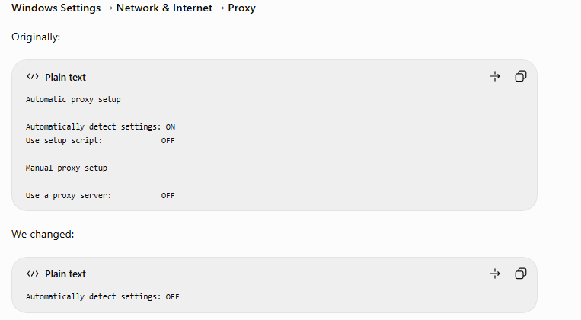

Then reopen the browser and use:
http://<ELB-URL>/

Check AWS LoadBalancer Health
aws elb describe-instance-health \
--region eu-north-1 \
--load-balancer-name <LOAD-BALANCER-NAME>

PART 26 — Install Argo CD
EC2
kubectl create namespace argocd
Then:
kubectl apply \
-n argocd \
--server-side \
--force-conflicts \
-f https://raw.githubusercontent.com/argoproj/argo-cd/stable/manifests/install.yaml
Check:
kubectl get pods \
-n argocd
Wait until they are running.
The official Argo CD getting-started guide uses this installation manifest and argocd namespace.

PART 27 — Argo CD Application creation first time on second skip this step if you pause the ec2 instance
Create:
vim argocd/application.yaml
Paste:
apiVersion: argoproj.io/v1alpha1
kind: Application

metadata:
name: student-management
namespace: argocd

spec:
project: default

source:
repoURL: https://github.com/harathi-mutyam/student-app-cicd.git
targetRevision: main
path: k8s

destination:
server: https://kubernetes.default.svc
namespace: student-management

syncPolicy:
automated:
prune: true
selfHeal: true

syncOptions:
- CreateNamespace=true
Apply:
kubectl apply \
-f argocd/application.yaml
Check:
kubectl get applications \
-n argocd
This is your CD engine.

kubectl get pods -n argocd

kubectl get svc -n argocd

Start port-forwarding on EC2
kubectl port-forward svc/argocd-server -n argocd 8080:443 --address=0.0.0.0

Allow port 8080 in the EC2 Security Group
Go to:
AWS Console → EC2 → Instances → your student server → Security → Security Groups → Inbound rules → Edit inbound rules
Type: Custom TCP
Port: 8080
Source: My IP
Description: Temporary Argo CD access

Copy public ip of student server
Open browserpaste the publicip:8080
Username: admin
Password:

Open another gitbash terminal
ssh -i Downloads/student-cicd-key.pem ubuntu@13.49.138.168
cd student-app-cicd
kubectl -n argocd get secret argocd-initial-admin-secret \
-o jsonpath="{.data.password}" | base64 -d && echo
Copy password paste it in browser login into argo cd and observe it
Username: admin
Password: <password from command>

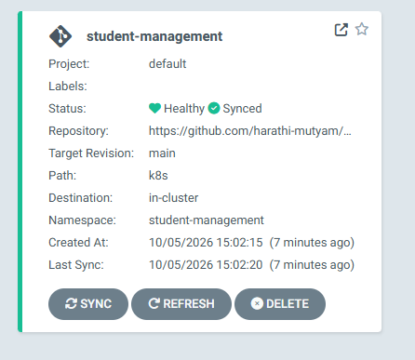
Press ctrl + c in the first git bash terminal

PART 28 — Install SonarQube on EC2 first time
We'll use Docker because it's easier for a beginner.
EC2
Run:
docker volume create sonarqube_data
Then:
docker run -d \
--name sonarqube \
--restart unless-stopped \
-p 9000:9000 \
-v sonarqube_data:/opt/sonarqube/data \
sonarqube:lts-community

We want to eventually see: SonarQube is operational

Check:
docker ps
Open:
http://YOUR_EC2_PUBLIC_IP:9000
Initial SonarQube credentials are normally:
admin
admin
Change the password when prompted.
if you are doing second time after pause and start the ec2 instance
try below steps with yellow colour

docker ps -a --filter name=sonarqube
docker start sonarqube
docker ps --filter name=sonarqube
docker logs --tail 30 sonarqube
http://YOUR_EC2_PUBLIC_IP:9000
username: admin
password: admin123

if you are using the ec2 instance server after pause and start skip step 29

PART 29 — Create SonarQube project
Inside SonarQube:
Create Project → manually Local project
Use:
Project display name:
Student Management System

Project key:
student-management-system
Then generate a token.
Copy it somewhere temporarily.
We'll put it into GitHub Secrets.
Change the SONAR_HOST_URL in github actions variables

PART 30 — Docker Hub token
Go to Docker Hub account settings/security and create an access token.
You need:
Docker Hub username
Docker Hub token
Do not put your Docker Hub password directly in ci.yml.

PART 31 — GitHub Secrets
Open your GitHub repository:
Settings → Secrets and variables → Actions
Create:
DOCKERHUB_USERNAME
value:
your Docker Hub username
Create:
DOCKERHUB_TOKEN
value:
your Docker Hub token
Create:
SONAR_TOKEN
value:
SonarQube token
Create:
SONAR_HOST_URL
value:
http://EC2_PUBLIC_IP:9000

IMPORTANT — SonarQube + GitHub-hosted runner problem
There's one architectural issue beginners often miss.
GitHub-hosted runners must be able to reach:
EC2:9000
If your EC2 security group allows port 9000 only from your laptop IP, GitHub Actions cannot reach SonarQube.
Don't solve that by permanently exposing SonarQube to the whole internet.
For your project, a better solution is:
GitHub
↓
Self-hosted GitHub Actions Runner
│
│ running on EC2
├── SonarQube localhost:9000
├── Docker
└── Git
This also makes your project more realistic.
So let's use your EC2 as the self-hosted CI runner.

PART 32 — Add EC2 as GitHub self-hosted runner
On GitHub:
Repository → Settings → Actions → Runners
Click:
New self-hosted runner
Select:
Linux
x64
GitHub will give you commands similar to:
mkdir actions-runner
cd actions-runner
and a current download command.
Use the exact commands GitHub shows you.
Then GitHub gives you something similar to:
./config.sh \
--url https://github.com/harathi-mutyam/student-app-cicd \
--token XXXXX

Enter the name of the runner group to add this runner to: [press Enter for Default] press enter key here

Enter the name of runner: [press Enter for studentserver] studentserver-runner

This runner will have the following labels: 'self-hosted', 'Linux', 'X64'
Enter any additional labels (ex. label-1,label-2): [press Enter to skip] self-hosted

√ Runner successfully added

# Runner settings

Enter name of work folder: [press Enter for _work] press enter here

Again, use the exact temporary token GitHub provides.
Then:
./run.sh
ubuntu@studentserver:~/actions-runner$ ./run.sh

√ Connected to GitHub

Current runner version: '2.337.0'
2026-10-05 06:51:46Z: Listening for Jobs

On GitHub you should see:
Runner status:
Idle

PART 33 — Run the runner as a service
After configuring it, stop ./run.sh with:
Ctrl+C
Then from inside actions-runner:
sudo ./svc.sh install
Start:
sudo ./svc.sh start
Check:
sudo ./svc.sh status
Now the runner survives SSH logout/restart.

PART 34 — CI/CD workflow
Now create:
cd ~/student-app-cicd
vim .github/workflows/ci.yml
For your beginner implementation, use the EC2 runner for all jobs:
name: Student Management CI/CD
on:
push:
branches:
- main

workflow_dispatch:

permissions:
contents: write

env:
PHP_IMAGE: ${{ vars.DOCKERHUB_USERNAME }}/student-management-php
PYTHON_IMAGE: ${{ vars.DOCKERHUB_USERNAME }}/student-management-python

jobs:

ci:
name: Test and Security
runs-on: self-hosted

steps:

- name: Checkout repository
uses: actions/checkout@v4
with:
fetch-depth: 0

- name: PHP Syntax Check
run: |
docker run --rm \
-v "$PWD:/app" \
-w /app \
php:8.2-cli \
sh -c 'find . -name "*.php" -exec php -l {} \;'

- name: Python Syntax Check
run: |
python3 -m compileall python/

- name: Gitleaks Secret Scan
uses: gitleaks/gitleaks-action@v2
env:
GITHUB_TOKEN: ${{ secrets.GITHUB_TOKEN }}

- name: SonarQube Scan
uses: SonarSource/sonarqube-scan-action@v6
env:
SONAR_TOKEN: ${{ secrets.SONAR_TOKEN }}
SONAR_HOST_URL: ${{ vars.SONAR_HOST_URL }}

docker:
name: Build and Push Images

needs:
- ci

runs-on: self-hosted

steps:

- name: Checkout repository
uses: actions/checkout@v4

- name: Create Image Tag
run: |
echo "IMAGE_TAG=${GITHUB_SHA::7}" >> $GITHUB_ENV

- name: Docker Login
uses: docker/login-action@v3
with:
username: ${{ vars.DOCKERHUB_USERNAME }}
password: ${{ secrets.DOCKERHUB_TOKEN }}

- name: Build PHP Image
run: |
docker build \
-t $PHP_IMAGE:$IMAGE_TAG \
.

- name: Push PHP Image
run: |
docker push \
$PHP_IMAGE:$IMAGE_TAG

- name: Build Python Image
run: |
docker build \
-t $PYTHON_IMAGE:$IMAGE_TAG \
./python

- name: Push Python Image
run: |
docker push \
$PYTHON_IMAGE:$IMAGE_TAG

- name: Update Kubernetes Images
run: |

sed -i \
"s|image: .*student-management-php:.*|image: $PHP_IMAGE:$IMAGE_TAG|" \
k8s/php-deployment.yaml

sed -i \
"s|image: .*student-management-python:.*|image: $PYTHON_IMAGE:$IMAGE_TAG|" \
k8s/python-deployment.yaml

- name: Commit Kubernetes Changes
run: |

git config user.name "github-actions[bot]"

git config user.email \
"41898282+github-actions[bot]@users.noreply.github.com"

git add \
k8s/php-deployment.yaml \
k8s/python-deployment.yaml

if git diff --cached --quiet
then
echo "No changes"
exit 0
fi

git commit \
-m "ci: deploy $IMAGE_TAG"

git push
I've deliberately kept this workflow simpler than the previous version.
First get this working.
Later we can separate it into:
php-ci
python-ci
gitleaks
sonarqube
docker
gitops-update
as independent jobs.

PART 35 — Add sonar-project.properties
At project root:
vim sonar-project.properties
Use:
sonar.projectKey=Student-Management-System
sonar.projectName=Student Management System

sonar.sources=admin,student,config,python,index.php

sonar.sourceEncoding=UTF-8

sonar.python.version=3

sonar.exclusions=**/vendor/**,**/__pycache__/**,k8s/**,argocd/**

Add for your existing token need to add the missing workflow permission.
Go to GitHub → Profile picture → Settings → Developer settings → Personal access tokens → Tokens—> select your Token edit select
☑ workflow
Update GitHub Action workflows

PART 36 — Commit your DevOps files
EC2
git status
Then:
git add .github/ argocd/ sonar-project.properties
git commit -m "Add complete CI CD pipeline"
git push origin main

PART 37 — Watch GitHub Actions
Go to:
GitHub repository → Actions
You should see:
Student Management CI/CD

Test and Security
↓
✓
↓
Build and Push Images
↓
✓
During CI:
PHP syntax
↓
Python syntax
↓
Gitleaks
↓
SonarQube
↓
Docker PHP
↓
Docker Python
↓
Docker Hub

PART 38 — Automatic GitOps deployment
Suppose the commit SHA is:
93f21a7
CI creates:
Docker Hub

student-management-php:93f21a7

student-management-python:93f21a7
Then CI changes:
image: username/student-management-php:initial
to:
image: username/student-management-php:93f21a7
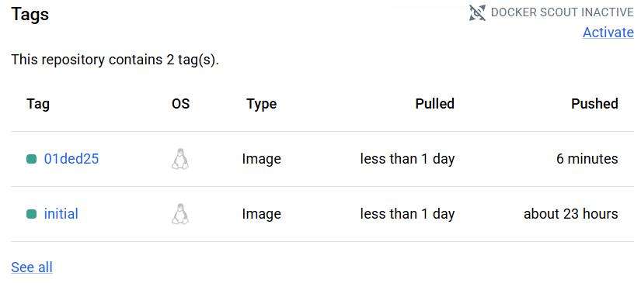
and commits that back to Git.
Then:
GitHub
│
│ changed K8s YAML
▼
Argo CD
│
│ detects change
▼
Automatic Sync
│
▼
EKS
│
├── New PHP pods
└── New Python pods
You don't run:
kubectl apply
after each application change.
That's the whole point of Argo CD GitOps.

PART 39 — Your normal developer workflow
Once everything works, your daily procedure becomes extremely simple.
Change: index.php page content
cd ~/student-app-cicd
vim index.php
git status
Then:
git add index.php
git commit -m "Update student home page"
git push origin main
Enter:
Username: harathi-mutyam
Password: <GitHub Personal Access Token>
If Push Is Rejected Because GitHub Has New Changes
rejected
fetch first
remote contains work that you do not have locally

Reason: GitHub contains a newer commit, usually because GitHub Actions updated the Kubernetes YAML.

Update EC2 Repository After CI/CD .

git pull --rebase origin main
git push origin main
it ask username and token enter it will success now

Everything else happens automatically:
YOU

git push
│
▼
GitHub
│
▼
Self-hosted GitHub Runner
│
├── Test
├── Gitleaks
├── SonarQube
├── Docker Build
├── Docker Push
└── Update YAML
│
▼
GitHub
│
▼
Argo CD
│
▼
EKS
│
▼
New Application

PART 40 — Verify deployment
From EC2:
kubectl get pods \
-n student-management
Then:
kubectl get deployments \
-n student-management
Check the deployed image:
kubectl get deployment \
student-management-php \
-n student-management \
-o=jsonpath='{.spec.template.spec.containers[0].image}'
You should see something like:
yourusername/student-management-php:93f21a7
Check services:
kubectl get svc \
-n student-management

PART 41 — Demonstrate self-healing
Your Git says:
replicas: 2
Run manually:
kubectl scale deployment student-management-php --replicas=1
-n student-management
Check:
kubectl get deployment student-management-php -n student-management
For a short time you'll see:
But because your deployment is controlled by Argo CD with selfHeal: true, Argo CD detects that Kubernetes has replicas: 1 while GitHub YAML says:
replicas: 2
and automatically restores it to 2 replicas.
That is actually proof that your Argo CD self-healing is working correctly. ✅
Verify it
Run:
kubectl get applications -n argocd
Then:
kubectl get deployment student-management-php -n student-management
You should continue seeing:
READY UP-TO-DATE AVAILABLE
2/2 2 2
Reason: Git contains replicas: 2, and Argo CD has:
syncPolicy:
automated:
prune: true
selfHeal: true
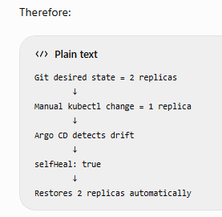

If you really want 1 replica
With GitOps, don't manually scale the deployment. Change the desired state in Git:
cd ~/student-app-cicd
vim k8s/php-deployment.yaml
Change: replicas: 2 to: replicas: 1
Then:
git status
git add k8s/php-deployment.yaml
git commit -m "Scale PHP deployment to 1 replica"
git pull --rebase origin main
git push origin main

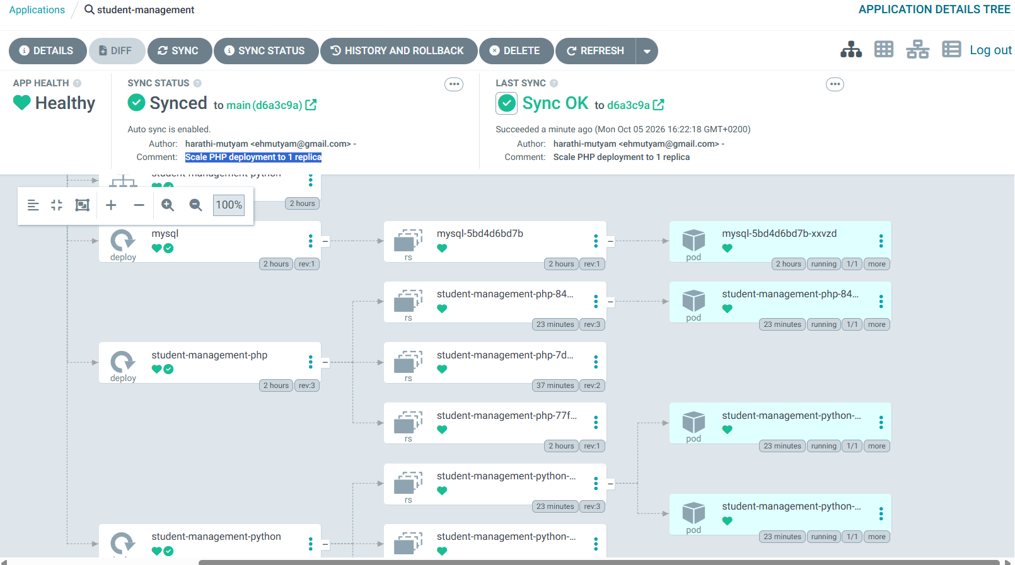

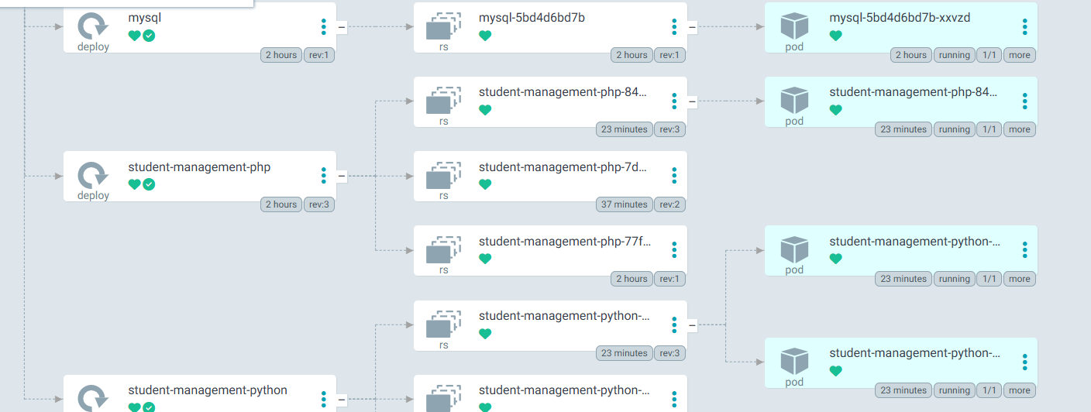

PART 42 — The final real-time architecture
Your project is now:
DEVELOPER
│
git push
│
▼
GitHub
│
▼
┌─────────────┐
│ EC2 RUNNER │
└──────┬──────┘
│
┌───────────┼────────────┐
│ │ │
▼ ▼ ▼
Tests Gitleaks SonarQube
│ │ │
└───────────┼────────────┘
│
PASS
│
▼
Docker Build
/ \
▼ ▼
PHP Python
\ /
▼ ▼
Docker Hub
│
Git SHA image
│
▼
Update K8s YAML
│
▼
GitHub
│
─────── CD ───────
│
▼
Argo CD
│
automated sync
prune + selfHeal
│
▼
AWS EKS
/ | \
▼ ▼ ▼
PHP Python MySQL
Pods Pods Pod
\ | /
\ | /
▼ ▼ ▼
APPLICATION
This is the version I'd recommend you implement first. Do not try to add Jenkins, Terraform, Helm, Prometheus, Grafana, ALB Ingress, RDS, Nexus, Ansible, etc. yet. Get this pipeline working from git push all the way to automatic EKS deployment first. After that, we can upgrade the same project one component at a time.
Continue with the same deployment
- Fix the Kubernetes manifests
- Create the GitHub Actions workflow

Prometheus + Grafana + Alertmanager stack inside EKS using Helm

PART 43 — Monitoring Architecture

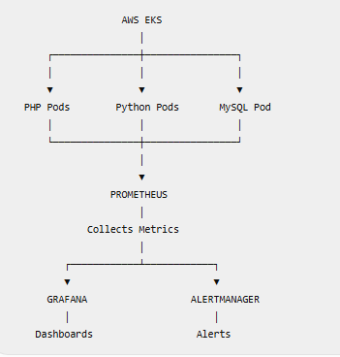
Prometheus = Collect metrics
Grafana = Display metrics/dashboard
Alertmanager = Manage and send alerts

PART 44 — Check Cluster Before Monitoring Installation
Run:
kubectl get nodes
Then:
kubectl get pods -n student-management
Make sure your nodes are Ready and application pods are Running.
Also check available resources:
kubectl top nodes
If this gives:
error: Metrics API not available
don't worry yet. We can handle that separately.

PART 45 — Install Helm
Check first:
helm version
If you get:
helm: command not found
install Helm:
curl https://raw.githubusercontent.com/helm/helm/main/scripts/get-helm-3 | bash
Check again:
helm version
You should see Helm version information.

PART 46 — Add Prometheus Helm Repository
Run:
helm repo add prometheus-community \
https://prometheus-community.github.io/helm-charts
Then:
helm repo update
Check:
helm repo list
You should see:
prometheus-community

PART 47 — Create Monitoring Namespace
Create a separate namespace:
kubectl create namespace monitoring
Check:
kubectl get namespaces
You should now have:
student-management
argocd
monitoring
Keeping monitoring separate makes administration easier:
student-management
└── Application

argocd
└── GitOps

monitoring
├── Prometheus
├── Grafana
└── Alertmanager

PART 48 — Install Prometheus + Grafana + Alertmanager
We will use:
kube-prometheus-stack
It installs the major monitoring components together.
Run:
helm install kube-prometheus-stack \
prometheus-community/kube-prometheus-stack \
--namespace monitoring
Wait a little and check:
kubectl get pods -n monitoring
You should eventually see components similar to:
alertmanager-kube-prometheus-stack-alertmanager-0
kube-prometheus-stack-grafana-xxxxx
kube-prometheus-stack-kube-state-metrics-xxxxx
kube-prometheus-stack-operator-xxxxx
prometheus-kube-prometheus-stack-prometheus-0
kube-prometheus-stack-prometheus-node-exporter-xxxxx
Wait until the important pods show:
Running
Check everything:
kubectl get all -n monitoring

PART 49 — Verify Prometheus
Check the Prometheus service:
kubectl get svc -n monitoring
Look for:
kube-prometheus-stack-prometheus
For beginner testing, use port-forwarding:
kubectl port-forward \
-n monitoring \
svc/kube-prometheus-stack-prometheus \
9090:9090 \
--address=0.0.0.0
Keep this terminal running.
In the EC2 Security Group temporarily allow:
Type: Custom TCP
Port: 9090
Source: My IP
Open:
http://EC2-PUBLIC-IP:9090
You should see the Prometheus UI.
After testing, press:
Ctrl+C
and remove the temporary 9090 Security Group rule.

PART 50 — Verify Grafana
Check:
kubectl get svc -n monitoring
Look for:
kube-prometheus-stack-grafana
Start:
kubectl port-forward \
-n monitoring \
svc/kube-prometheus-stack-grafana \
3000:80 \
--address=0.0.0.0
Keep this terminal running.
Temporarily allow EC2 Security Group:
Type: Custom TCP
Port: 3000
Source: My IP
Open:
http://EC2-PUBLIC-IP:3000

PART 51 — Get Grafana Password
Open another SSH terminal and run:
kubectl get secret \
kube-prometheus-stack-grafana \
-n monitoring \
-o jsonpath="{.data.admin-password}" \
| base64 --decode; echo
Grafana username:
admin
Password:
<output from above command>
Log in to Grafana.

PART 52 — Check Grafana Dashboards
After logging in, go to:
Dashboards
The stack automatically installs Kubernetes monitoring dashboards.
You can monitor things such as:
EKS Cluster
│
├── Nodes
│ ├── CPU
│ ├── Memory
│ └── Network
│
├── Namespaces
│
├── Deployments
│
└── Pods
├── CPU
├── Memory
├── Restarts
└── Status
Search the Grafana dashboards for Kubernetes/node/pod dashboards.

PART 53 — Verify Prometheus Targets
Open Prometheus and go to:
Status
→ Target health
You should see many targets with:
UP
Prometheus will collect Kubernetes infrastructure metrics through components including:
Prometheus
├── Kubernetes API
├── kube-state-metrics
├── node-exporter
└── Kubernetes components

PART 54 — Test Prometheus with PromQL
PromQL is the query language used by Prometheus to check Kubernetes metrics.
Step 1 — Start Prometheus Port Forward
On EC2:
kubectl port-forward \
-n monitoring \
svc/kube-prometheus-stack-prometheus \
9090:9090 \
--address=0.0.0.0
Expected:
Forwarding from 0.0.0.0:9090 -> 9090
Keep this terminal running.
Open:
http://<EC2-PUBLIC-IP>:9090

Step 2 — Check Whether Prometheus Targets Are UP
In Prometheus, enter:
up
Click Execute.
Expected:
1
Meaning:
1 = Target is UP
0 = Target is DOWN

Step 3 — Check Kubernetes Pod Metrics
Run:
kube_pod_status_phase
This displays pod status information from Kubernetes.

Step 4 — Check Only Our Application
Run:
kube_pod_status_phase{namespace="student-management"}
This filters the results to our application namespace.
We should see metrics for:
student-management
│
├── PHP Pods
├── Python Pods
└── MySQL Pod
If results appear, Prometheus is monitoring our application namespace.

Step 5 — Check CPU Usage
Run:
rate(
container_cpu_usage_seconds_total{
namespace="student-management",
container!=""
}[5m]
)
This shows CPU usage for our application containers.

Step 6 — Check Memory Usage
Run:
container_memory_working_set_bytes{
namespace="student-management",
container!=""
}
This shows memory consumption for our application containers.

PART 54 — Verification
These queries should return results:
up ✓

kube_pod_status_phase ✓

kube_pod_status_phase{
namespace="student-management"
} ✓

CPU query ✓

Memory query ✓
If all return data:
PART 54 COMPLETE
Prometheus is monitoring Kubernetes successfully.

PART 55 — Verify Alertmanager
Alertmanager handles alerts generated by Prometheus.
Flow:
Problem occurs Prometheus detects it Prometheus Alert Rule Alertmanager Notification Example: -->PHP Pod Down Prometheus detects it Alert becomes FIRING Alertmanager receives it
Step 1 — Check Alertmanager Pod
Run:
kubectl get pods -n monitoring | grep alertmanager
Expected similar output:
alertmanager-kube-prometheus-stack-alertmanager-0 2/2 Running
Important:
STATUS = Running

Step 2 — Check Alertmanager Service
Run:
kubectl get svc -n monitoring | grep alertmanager
You should see:
kube-prometheus-stack-alertmanager

Step 3 — Start Alertmanager Port Forward
Run:
kubectl port-forward \
-n monitoring \
svc/kube-prometheus-stack-alertmanager \
9093:9093 \
--address=0.0.0.0
Expected:
Forwarding from 0.0.0.0:9093 -> 9093
Keep this terminal running.

Step 4 — Allow Port 9093 Temporarily
AWS Console: EC2 → Instances → studentserver → Security→ Security Group → Edit inbound rules Add:
Type: Custom TCP
Port: 9093
Source: My IP
Description: Alertmanager temporary access
Save the rule.

Step 5 — Open Alertmanager
Browser:
http://<EC2-PUBLIC-IP>:9093
You should see the Alertmanager UI.
It is okay if there are currently no application alerts.
We are only verifying that Alertmanager is working.

Step 6 — After Testing
Stop the port-forward:
Ctrl+C
Remove the temporary Security Group rule:
TCP 9093

PART 56 — Verify Complete Monitoring Stack
Run:
kubectl get pods -n monitoring
We should have:
Prometheus Running
Grafana Running
Alertmanager Running
Node Exporter Running
kube-state-metrics Running
Prometheus Operator Running
Check services:
kubectl get svc -n monitoring
Check Helm:
helm list -n monitoring
You should see:
kube-prometheus-stack

PART 56 — Monitoring Architecture
Our monitoring works like this:
AWS EKS
│
┌────────────┼────────────┐
│ │ │
▼ ▼ ▼
PHP Pods Python Pods MySQL Pod
│ │ │
└────────────┼────────────┘
│
▼
PROMETHEUS
│
Collect Metrics
│
┌──────────┴──────────┐
│ │
▼ ▼
GRAFANA ALERTMANAGER
│ │
▼ ▼
Dashboards Alerts
Simple explanation:
Prometheus
↓
Collects metrics
CPU, Memory, Pod Status, etc.

Grafana
↓
Displays Prometheus data
as dashboards and graphs

Alertmanager
↓
Handles alerts generated
by Prometheus
So remember:
Prometheus = Collect Metrics

Grafana = Show Metrics

Alertmanager = Handle Alerts

PART 57 — Monitor Student Management Application
Now we move from general Kubernetes monitoring to our actual application monitoring.
We want to monitor:
student-management
│
├── PHP
│ ├── Pod Status
│ ├── CPU
│ ├── Memory
│ └── Restarts
│
├── Python
│ ├── Pod Status
│ ├── CPU
│ ├── Memory
│ └── Restarts
│
└── MySQL
├── Pod Status
├── CPU
├── Memory
└── Restarts
First check our pods:
kubectl get pods -n student-management
All should be:
Running
Then in Prometheus run:
kube_pod_info{namespace="student-management"}
This confirms Prometheus knows about our application pods.
Then check running pods:
kube_pod_status_phase{
namespace="student-management",
phase="Running"
}

PART 58 — Create Student Management Grafana Dashboard
After PART 57, we will create our own Grafana dashboard.
Our dashboard will contain:
STUDENT MANAGEMENT MONITORING
│
┌────────────┼─────────────┐
│ │ │
▼ ▼ ▼
PHP Python MySQL
│ │ │
├─ CPU ├─ CPU ├─ CPU
├─ Memory ├─ Memory ├─ Memory
├─ Status ├─ Status ├─ Status
└─ Restarts └─ Restarts └─ Restarts

Yes. Based on everything we actually did in your project, below is the complete Loki logging procedure from start to finish, including the problems we encountered, the final working configuration, Alloy, Grafana, LogQL, and dashboard creation.
This is specifically for your current architecture:
AWS EKS: student-cluster
Region: eu-north-1

Application namespace:
student-management

Monitoring namespace:
monitoring

Logging namespace:
logging

Application
├── PHP
├── Python
└── MySQL
│
▼
Grafana Alloy
│
▼
Loki
│
▼
Grafana
PART 1 — Verify EKS Connection
Run everything from your Ubuntu EC2 studentserver.
Go to the project:
cd ~/student-app-cicd
Confirm Kubernetes connectivity:
kubectl get nodes
You should have your two EKS nodes in Ready state.
Check your application:
kubectl get pods -n student-management
In your working setup, MySQL, PHP and both Python replicas were running. Pasted text

PART 2 — Create Logging Namespace
Check namespaces:
kubectl get namespaces
If logging does not exist:
kubectl create namespace logging
Verify:
kubectl get namespace logging

PART 3 — Add Grafana Helm Repository
Add the repository:
helm repo add grafana https://grafana.github.io/helm-charts
Update:
helm repo update
Check:
helm repo list
In our setup we ultimately had the Grafana chart repository available for Alloy.
helm search repo grafana/loki

PART 4 — Create Loki Configuration
Create the directory if necessary:
mkdir -p logging
Open:
vim logging/loki-values.yaml
Press:
i
Paste the final configuration we used:
deploymentMode: SingleBinary

loki:
auth_enabled: false

commonConfig:
replication_factor: 1

schemaConfig:
configs:
- from: "2024-04-01"
store: tsdb
object_store: filesystem
schema: v13
index:
prefix: loki_index_
period: 24h

storage:
type: filesystem

pattern_ingester:
enabled: true

limits_config:
allow_structured_metadata: true
volume_enabled: true

rulerConfig:
enable_api: true

minio:
enabled: false

singleBinary:
replicas: 1

persistence:
enabled: false

chunksCache:
enabled: false

resultsCache:
enabled: false

backend:
replicas: 0

read:
replicas: 0

write:
replicas: 0

ingester:
replicas: 0

querier:
replicas: 0

queryFrontend:
replicas: 0

queryScheduler:
replicas: 0

distributor:
replicas: 0

compactor:
replicas: 0

indexGateway:
replicas: 0

bloomPlanner:
replicas: 0

bloomBuilder:
replicas: 0

bloomGateway:
replicas: 0
Save Esc , :wq ,Enter key

PART 5 — Why We Used This Loki Configuration
Initially we encountered two major problems.
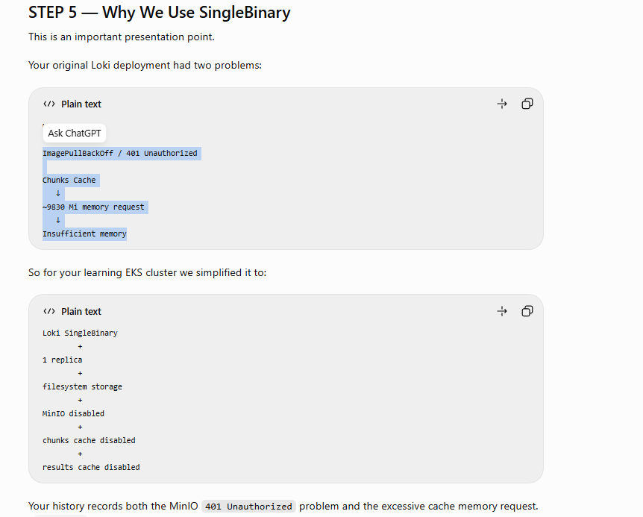
The MinIO image failed with:
401 Unauthorized
and Loki's cache requested too much memory—approximately:
9830Mi
which caused:
Insufficient memory
Therefore, for this learning project we simplified Loki to:
SingleBinary Loki
+
filesystem storage
+
no MinIO
+
no chunks cache
+
no results cache
This is much more appropriate for your small two-node learning cluster.
Important limitation
We deliberately configured:
persistence:
enabled: false
Therefore /var/loki is ephemeral.
This means:
Loki pod deleted/recreated
↓
Old Loki log data may be lost
This setup is good for learning/testing, not the final production architecture.
For production we would normally move Loki storage to durable object storage such as S3.

Because this is a small learning cluster, I deployed Loki in SingleBinary mode. For a production environment, I would use a scalable Loki architecture with durable object storage such as Amazon S3.

STEP 6 — Validate the YAML
Before installation:
grep -E "deploymentMode:|enabled: false|replicas:" logging/loki-values.yaml
You should see approximately:
deploymentMode: SingleBinary
auth_enabled: false
enabled: false
replicas: 1
enabled: false
enabled: false
enabled: false
replicas: 0
replicas: 0
...
Your actual run produced exactly this pattern: SingleBinary, one replica, and the other deployment components at zero replicas. Pasted text
The multiple:
replicas: 0
entries are correct, not errors.

PART 6 — Install Loki

STEP 7 — Install Loki
Use this corrected command consistently:
helm upgrade --install loki grafana/loki \
-n logging \
-f logging/loki-values.yaml
Using upgrade --install is useful because the same command handles both:
Loki doesn't exist → Install

Loki already exists → Upgrade
Your later history also records this as the reinstall command. Pasted text
Check:
helm list -n logging
Your successful installation showed Loki deployed with chart loki-18.13.8, app version 3.7.8.
Check pods:
kubectl get pods -n logging
We eventually had:
loki-0 2/2 Running
loki-canary-... 1/1 Running
loki-canary-... 1/1 Running
loki-gateway-... 2/2 Running

PART 7 — Check Loki Services
Run:
kubectl get svc -n logging
We had services including:
loki
loki-canary
loki-gateway
loki-gateway-exporter
loki-headless
loki-memberlist
The important service for our architecture is:
loki-gateway
Alloy and Grafana communicate with Loki through this gateway.

PART 8 — Test Loki Health
We used port forwarding for command-line testing:
kubectl port-forward -n logging svc/loki 3100:3100
At one point you got:
bind: address already in use
because port 3100 was already being forwarded.
We confirmed Loki was available using:
Keep that terminal running.
From another SSH terminal:

curl http://localhost:3100/ready
and received:
ready

That confirmed:
Loki Pod
↓
Service
↓
Port forward
↓
localhost:3100
↓
READY

Open Ec2 instance security group student-app-sg edit inbound rules
IPv4 | Custom TCP | TCP | 3100 | 0.0.0.0/0

You do not need to expose Loki port 3100 publicly through the EC2 Security Group.

sudo ss -ltnp | grep :3100

PART 9 — Install Grafana Alloy
Now we need something to collect Kubernetes pod logs.
Create:
vim logging/alloy-values.yaml
Paste:
alloy:
configMap:
content: |
logging {
level = "info"
format = "logfmt"
}

discovery.kubernetes "pods" {
role = "pod"
}

discovery.relabel "pod_logs" {
targets = discovery.kubernetes.pods.targets

rule {
source_labels = ["__meta_kubernetes_namespace"]
target_label = "namespace"
}

rule {
source_labels = ["__meta_kubernetes_pod_name"]
target_label = "pod"
}

rule {
source_labels = ["__meta_kubernetes_pod_container_name"]
target_label = "container"
}

rule {
source_labels = ["__meta_kubernetes_pod_label_app"]
target_label = "app"
}
}

loki.source.kubernetes "pods" {
targets = discovery.relabel.pod_logs.output
forward_to = [loki.write.local.receiver]
}

loki.write "local" {
endpoint {
url = "http://loki-gateway.logging.svc.cluster.local/loki/api/v1/push"
}
}
Save:
Esc
:wq

PART 10 — Understand the Loki Internal URL/address
The important URL is:
http://loki-gateway.logging.svc.cluster.local
Alloy uses:
http://loki-gateway.logging.svc.cluster.local/loki/api/v1/push

Kubernetes DNS follows:
SERVICE.NAMESPACE.svc.cluster.local
Therefore:
Service:
loki-gateway

Namespace:
logging

↓

loki-gateway.logging.svc.cluster.local
Alloy sends logs to:
http://loki-gateway.logging.svc.cluster.local/loki/api/v1/push

PART 11 — Install Alloy
Run:
helm upgrade --install alloy grafana/alloy \
-f logging/alloy-values.yaml \
-n logging
Your successful installation showed:
alloy logging deployed alloy-1.13.0 v1.20.0
loki logging deployed loki-18.13.8 3.7.8
helm list -n logging

Check:
kubectl get pods -n logging
In your successful installation Alloy ran two pods, one on each node. Pasted text

Eventually both Alloy pods became:
alloy-lsgmm 2/2 Running
alloy-p77nv 2/2 Running

PART 12 — Why There Are Two Alloy Pods Verify Alloy DaemonSet
Run:
kubectl get daemonset -n logging
We confirmed:
NAME DESIRED CURRENT READY AVAILABLE
alloy 2 2 2 2
Alloy is running as a DaemonSet.
Alloy runs as a DaemonSet. Therefore Kubernetes runs an Alloy pod on each EKS worker node, allowing it to collect logs from workloads across the cluster.
Because your EKS cluster has two worker nodes:
EKS Node 1
↓
Alloy Pod

EKS Node 2
↓
Alloy Pod
This is why there are two Alloy pods.

PART 13 — Correct Way to Check Alloy Logs
That was because Alloy is a DaemonSet, not a Deployment.
The correct command is:
kubectl logs -n logging daemonset/alloy -c alloy --tail=50
You can also inspect individual pods:
kubectl logs -n logging alloy-lsgmm -c alloy --tail=30
and:
kubectl logs -n logging alloy-p77nv -c alloy --tail=30

PART 14 — Verify Alloy Is Collecting Application Logs
This was a major successful checkpoint.
Alloy showed:
opened log stream
That indicates Alloy is reading Kubernetes logs.
for your Python application. Pasted text
It also opened the PHP log stream. Pasted text
That proved:
Application Pods
↓
Alloy
↓
logs being collected

PART 15 — Verify Loki Received the Logs
We queried Loki:
curl -s http://localhost:3100/loki/api/v1/label/namespace/values
Your actual response was:
{"status":"success","data":["argocd","kube-system","logging","monitoring","student-management"]}
Pasted text
The critical value was:
student-management
Your project produced that namespace in Loki.
student-management Pods
↓
Alloy
↓
Loki Gateway
↓
Loki
↓
Logs successfully stored/queryable
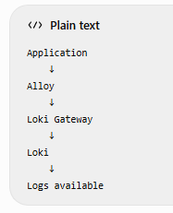

PART 16 — Add Loki to Grafana
Your Grafana is already accessible from your browser through:
Grafana dashboard
In Grafana go to:
Connections Data sources Add new data source search : Loki select :Loki
Important: On the Add data source screen, search for:
Loki
Do not put the Loki URL into the data-source search field.
After selecting Loki, configure:
Name:
Loki

URL:
http://loki-gateway.logging.svc.cluster.local

Authentication:
No Authentication
Leave advanced options at their defaults.
Then:
Save & test
You received:
Data source successfully connected.
So:
Grafana Loki Gateway Loki SUCCESS
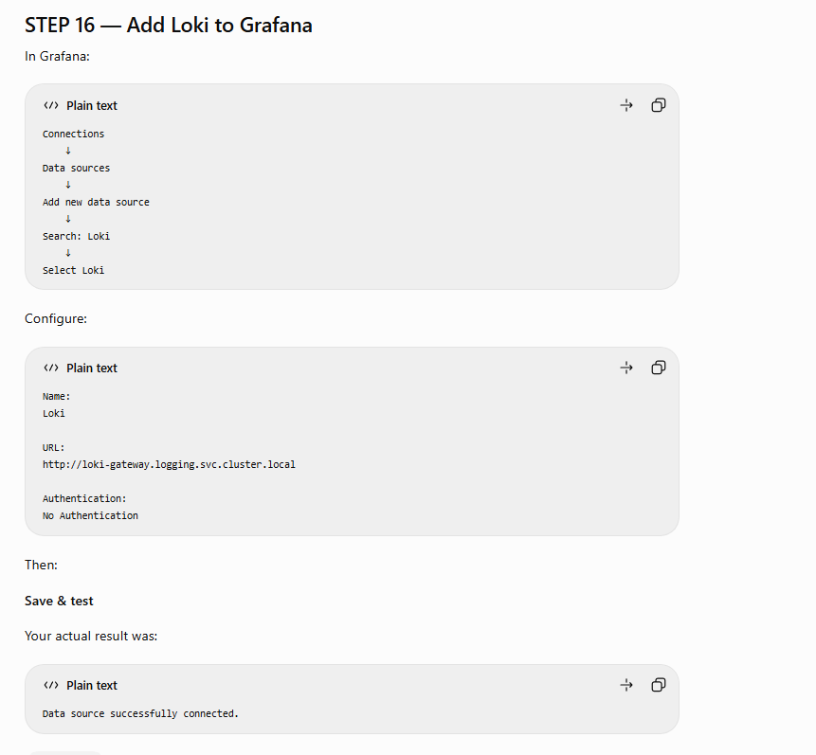

PART 17 — Why Grafana Does Not Use the EC2 IP for Loki
This distinction is important.
You access Grafana through:
Your Computer
↓
EC2 Public IP : 3000
↓
Grafana
But Grafana accesses Loki internally:
Grafana
↓
loki-gateway.logging.svc.cluster.local
↓
Loki
Therefore Grafana's Loki URL is not:
http://13.50.250.227:3100
and not:
http://localhost:3100
It is:
http://loki-gateway.logging.svc.cluster.local

PART 18 — Test Loki in Grafana Explore
Open:
Explore
Select:
Loki
Use Code mode.
To see all application logs:
{namespace="student-management"}
Set time range, for example:
Last 1 hour
or:
Last 6 hours
Click:
Run query
This successfully displayed your application logs.
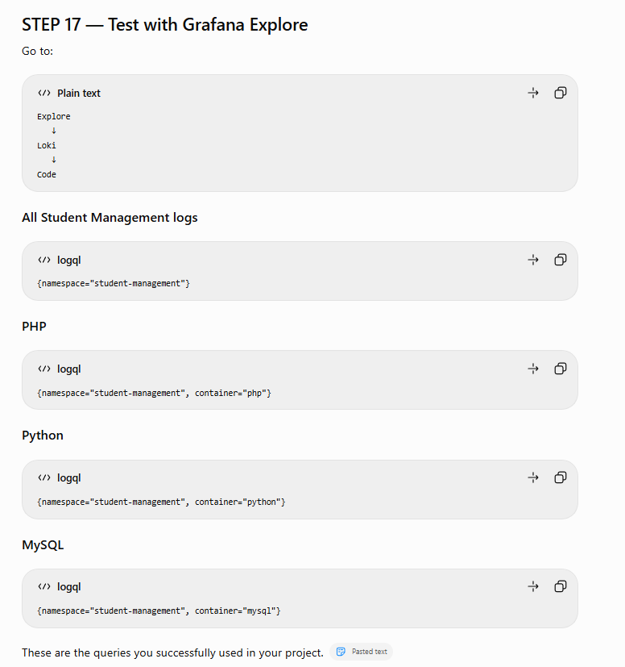

PART 19 — PHP Logs
Use:
{namespace="student-management", container="php"}
This displays only PHP container logs.

PART 20 — Python Logs
Use:
{namespace="student-management", container="python"}
You have two Python replicas, so logs from both pods can appear.

PART 21 — MySQL Logs
Use:
{namespace="student-management", container="mysql"}
This displays only MySQL logs.

PART 22 — Search for Errors
All application lines containing error, case-insensitive:
{namespace="student-management"} |~ "(?i)error"
PHP logs containing 404:
{namespace="student-management", container="php"} |= "404"
PHP logs containing 400:
{namespace="student-management", container="php"} |= "400"
Search warnings:
{namespace="student-management"} |~ "(?i)warning"

PART 23 — Create Grafana Loki Dashboard
Go to:
Dashboards New New dashboard Add panel Select:
Loki
We named the dashboard:
Student Management - Loki Logs

Go Dashboards

Yes. Based on the Grafana screens you showed earlier, here is STEP 19–20 in the exact click-by-click order. This creates the first panel only. After this is saved correctly, you add PHP, Python, and MySQL panels.

STEP 19 — Create Student Management - Loki Logs
You already added the Loki data source and got Data source successfully connected, so start from the normal Grafana screen.

19.1 Open Dashboards
On the left-side Grafana menu, click:
Dashboards
You will reach the Dashboards page.
Click:
New → New dashboard
You should now see a new empty dashboard.

19.2 Add the first visualization
On the empty dashboard, click:
+ Add visualization
Grafana will ask you to choose a data source.
Select:
Loki
Do not choose Prometheus here.
You should now enter the Edit panel screen, similar to the screens you showed previously.

STEP 20 — Configure the first panel
This first panel will display all logs from your student-management namespace.

20.1 Check the data source
At the bottom of the panel editor, make sure the data source shows:
Loki

20.2 Select Code mode
In the query section you should see Builder / Code.
Click:
Code
You should now have a query box.

20.3 Enter the LogQL query
Delete anything already in the query box and enter exactly:
{namespace="student-management"}
So your query area should look approximately like:
A Loki

Builder [Code]

{namespace="student-management"}

[Run queries]
Then click:
Run queries

20.4 Confirm that logs appear
You should now see log entries in the large preview area.
Based on the logs you showed previously, this query should combine logs from the application containers rather than restricting the result to only PHP or Python.
Conceptually:
{namespace="student-management"}

↓

┌─────────────────────────────┐
│ student-management │
│ │
│ PHP logs │
│ Python logs │
│ MySQL logs │
└─────────────────────────────┘
If you see logs, continue.
If you see No data, don't create the panel yet. First change the Grafana time selector in the upper-right from a short period to:
Last 6 hours
and run the query again.

20.5 Select the Logs visualization
Look at the right-hand side of the panel editor.
Find the visualization selector.
Choose:
Logs
This is important. We are displaying raw application logs, so don't select:
Time series
Stat
Gauge
Table
For this first panel use:
Visualization = Logs

20.6 Give the panel its title
On the right side, find:
Panel options
Under Title, enter:
Student Management - Application Logs
At this stage you should have exactly:
Data source:
Loki

Query:
{namespace="student-management"}

Visualization:
Logs

Panel title:
Student Management - Application Logs

STEP 20.7 — Save the panel/dashboard
Now click Save in the upper-right.
Because this is the first panel of a new dashboard, Grafana may ask you for the dashboard name.
Enter exactly:
Student Management - Loki Logs
Then confirm:
Save
Be careful with these two names:
DASHBOARD NAME
Student Management - Loki Logs

≠

PANEL NAME
Student Management - Application Logs
The dashboard is the complete page. The panel is only one box inside that page.

What you should see after saving
Your screen should now look conceptually like this:
Dashboard:
Student Management - Loki Logs
────────────────────────────────────────────

┌───────────────────────────────────────────┐
│ Student Management - Application Logs │
│ │
│ 10.0.x.x ... GET / ... │
│ Python/Flask logs ... │
│ PHP/Apache logs ... │
│ MySQL logs ... │
│ │
└───────────────────────────────────────────┘
This matches the dashboard structure you later built in your previous screenshots: the first panel contained all application logs, followed by separate PHP, Python, and MySQL panels. Pasted text

Important: don't create another dashboard for the next panel
Once this is saved, stay inside:
Student Management - Loki Logs
For the next panel you will use:
Add panel → Add visualization → Loki
and create:
PHP Application Logs

Query:
{namespace="student-management", container="php"}
That panel must be added to the same dashboard, not another new dashboard.
If you're currently looking at the Grafana screen, complete only the first panel above.
Continue with the same dashboard
- Add the PHP logs panel
- Fix a “No data” result

PART 24 — Panel 1: All Application Logs
Data source:
Loki
Query:
{namespace="student-management"}
Visualization:
Logs
Title:
Student Management - Application Logs
Save it.

PART 25 — Panel 2: PHP Application Logs
From the existing dashboard:
Add panel
↓
Visualization
↓
Loki
Query:
{namespace="student-management", container="php"}
Visualization:
Logs
Title:
PHP Application Logs
Save it to the existing dashboard, not a new dashboard.

PART 26 — Panel 3: Python Application Logs
Query:
{namespace="student-management", container="python"}
Visualization:
Logs
Title:
Python Application Logs
Save.

PART 27 — Panel 4: MySQL Application Logs
Query:
{namespace="student-management", container="mysql"}
Visualization:
Logs
Title:
MySQL Application Logs
Save.
Your dashboard now has:
STUDENT MANAGEMENT - LOKI LOGS

┌──────────────────────────────┬──────────────────────────────┐
│ Student Management │ PHP Application │
│ Application Logs │ Logs │
├──────────────────────────────┼──────────────────────────────┤
│ Python Application │ MySQL Application │
│ Logs │ Logs │
└──────────────────────────────┴──────────────────────────────┘

PART 28 — Panel 5: HTTP 4xx Errors
This is the next step we were working on.
Add another panel:
Add panel
→ Visualization
→ Loki
Use:
sum(
count_over_time(
{namespace="student-management", container="php"}
|~ "\" 4[0-9][0-9] "
[$__auto]
)
)
Visualization:
Stat
Title:
HTTP 4xx Errors
This counts HTTP client errors such as:
400
401
403
404

PART 29 — Panel 6: HTTP 5xx Errors
After the 4xx panel, create another Stat panel.
Use:
sum(
count_over_time(
{namespace="student-management", container="php"}
|~ "\" 5[0-9][0-9] "
[$__auto]
)
)
Visualization:
Stat
Title:
HTTP 5xx Errors
This is particularly useful because:
4xx
→ client/request problem

5xx
→ server/application problem

PART 30 — Useful LogQL Cheat Sheet
All project logs:
{namespace="student-management"}
PHP:
{namespace="student-management", container="php"}
Python:
{namespace="student-management", container="python"}
MySQL:
{namespace="student-management", container="mysql"}
Errors:
{namespace="student-management"} |~ "(?i)error"
Warnings:
{namespace="student-management"} |~ "(?i)warning"
404:
{namespace="student-management", container="php"} |= "404"
4xx count:
sum(count_over_time({namespace="student-management", container="php"} |~ "\" 4[0-9][0-9] " [$__auto]))
5xx count:
sum(count_over_time({namespace="student-management", container="php"} |~ "\" 5[0-9][0-9] " [$__auto]))

PART 31 — Final Architecture
You have now implemented:
INTERNET
│
▼
Student Application
│
┌─────────┼─────────┐
▼ ▼ ▼
PHP Python MySQL
│ │ │
└─────────┼─────────┘
│
Container Logs
│
▼
Grafana Alloy
DaemonSet
1 per EKS node
│
│ /loki/api/v1/push
▼
Loki Gateway
│
▼
Loki
SingleBinary
│
▼
Grafana
│
┌─────────┴─────────┐
▼ ▼
Explore Dashboard
│ │
▼ ▼
LogQL Application Logs
PHP Logs
Python Logs
MySQL Logs
4xx Errors
5xx Errors
The three monitoring technologies in your project
You can now distinguish the roles clearly:
Prometheus
→ collects METRICS
→ CPU, memory, pod metrics, request metrics
→ PromQL

Alertmanager
→ receives and routes ALERTS
→ notifications / alert handling

Loki + Alloy
→ collects LOGS
→ PHP/Python/MySQL/Kubernetes logs
→ LogQL

Grafana
→ visualizes metrics and logs
→ dashboards
One important note for your project documentation: your current Loki storage is intentionally non-persistent. It is suitable for this training project, but a production implementation should use durable storage—typically object storage such as S3—before treating Loki as a long-term logging platform.

We have Loki + Alloy in logging, Prometheus/Grafana/Alertmanager in monitoring, our application in student-management, and the EKS cluster student-cluster. Pasted text
If by deletion procedure you mean delete the complete AWS/EKS project and avoid AWS charges, use this order.
1. First confirm you are connected to the correct cluster
Run from:
ubuntu@studentserver:~$
or:
cd ~/student-app-cicd
Then:
kubectl get nodes
kubectl get namespaces
helm list -A
Do not start by deleting the EC2 instance.
2. Delete Loki + Alloy first
Check:
helm list -n logging
You should see loki and alloy, because these were installed as Helm releases in your logging namespace.
Delete them:
helm uninstall alloy -n logging
helm uninstall loki -n logging
Then:
kubectl delete namespace logging
Verify:
kubectl get namespace logging
Expected:
Error from server (NotFound)
3. Delete Prometheus + Grafana + Alertmanager
Check:
helm list -n monitoring
Then:
helm uninstall kube-prometheus-stack -n monitoring
Delete namespace:
kubectl delete namespace monitoring
Verify:
kubectl get namespace monitoring
This removes the monitoring stack you installed with kube-prometheus-stack. Pasted text
4. Delete Argo CD
First check:
kubectl get applications -n argocd
Delete your application:
kubectl delete application student-management -n argocd
Then delete Argo CD:
kubectl delete namespace argocd
Check:
kubectl get namespace argocd
5. Delete Student Management application
Now:
kubectl delete namespace student-management
Check:
kubectl get namespace student-management
At this point your application, PHP, Python and MySQL Kubernetes resources should be gone.
6. IMPORTANT — Delete EKS using Terraform
Your project created the infrastructure using Terraform:
cd ~/student-app-cicd/terraform
First:
terraform state list
Then:
terraform plan -destroy -var-file="dev.tfvars"
Review the output carefully.
If it looks correct:
terraform destroy -var-file="dev.tfvars"
Terraform will ask:
Do you really want to destroy all resources?
Enter:
yes
Wait until you get:
Destroy complete!
Because you created the EKS infrastructure with Terraform, use terraform destroy rather than separately running eksctl delete cluster. Mixing deletion methods can leave Terraform state inconsistent.
7. Verify AWS resources are gone
Your project is using eu-north-1, so check:
aws eks list-clusters --region eu-north-1
Then check load balancers:
aws elb describe-load-balancers \
--region eu-north-1 \
--query 'LoadBalancerDescriptions[*].LoadBalancerName' \
--output table
Check EBS volumes:
aws ec2 describe-volumes \
--region eu-north-1 \
--query 'Volumes[*].[VolumeId,State,Size,Tags]' \
--output table
Also check:
aws ec2 describe-nat-gateways \
--region eu-north-1 \
--filter Name=state,Values=available,pending \
--query 'NatGateways[*].[NatGatewayId,State,VpcId]' \
--output table
Pay particular attention to leftover Load Balancers, EBS volumes and NAT Gateways, because these can continue generating charges.
8. Delete SonarQube from EC2
If you're going to delete the EC2 instance anyway, this isn't strictly necessary. But for a clean teardown:
docker stop sonarqube
docker rm sonarqube
docker volume rm sonarqube_data
Check:
docker ps -a
docker volume ls
9. Remove GitHub self-hosted runner
Before terminating EC2, go to your GitHub repository:
Settings → Actions → Runners
Remove:
studentserver-runner
You don't need to delete your GitHub repository unless you actually want to remove the project/source code.
10. Finally terminate the EC2 studentserver
Only after Terraform destruction has completed successfully:
AWS Console → EC2 → Instances → studentserver → Instance state → Terminate instance
Then check your AWS console for remaining resources.
The safe deletion sequence is therefore:
Loki + Alloy
↓
Monitoring
↓
Argo CD
↓
Student Application
↓
Terraform Destroy
↓
Verify EKS / ELB / EBS / NAT
↓
Remove GitHub Runner
↓
Terminate studentserver EC2
Do not delete the EC2 studentserver first, because you're currently using it to administer Terraform, kubectl, Helm, AWS CLI, and the EKS cluster.
Useful checks before teardown
- Create a deletion checklist
- Add rollback and safety checks

